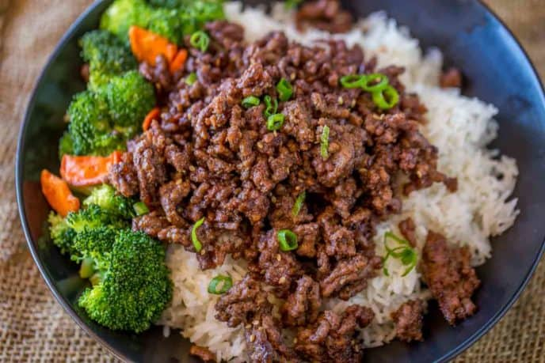
Ground Mongolian Beef
Prep time 10 min Cook time 10 min
4 Servings
Ingredients
2 cups uncooked rice
1 lb lean ground beef
1 tbsp sesame oil
3 cloves garlic minced
2 tbsp fresh ginger, minced or 1 tbsp ground ginger
2 tbsp mirin (or ½ tbsp of sugar and 2 tbsp white wine)
2 tbsp rice vinegar
½ cup brown sugar
¼ cup lite soy sauce
1 tsp sesame seeds
¼ tsp crushed red pepper flakes
½ cup chopped scallions
Directions
- Prepare rice according to package directions.
- Heat a large pan over medium high heat.
- Brown the meat very deeply with sesame oil.
- Once browned, drain most of the fat, then add the garlic and ginger.
- Add the mirin, rice vinegar, brown sugar, soy sauce, sesame seeds and red pepper flakes.
- Cook until the liquid has re-absorbed and the meat is shiny but not soupy.
- Top with green onions, toss together and serve over rice.

